**Rajan Gautam**

**19BCP101**

**Div. II, CE 19**

**SOT, PDPU**

**Pandit Deendayal Energy University**

**School of Technology**

**Design Pattern and Thinking (20CP210P)**

**B. Tech - Computer Science & Engineering (Sem-IV)**

**Table of Contents**

**Lab 3 Assignment: Prototype Design Pattern for Car 1**

**AIM: To write a Java Program to implement Prototype Design Pattern Car 1**

**CODE: 1**

**RajanGautam_Car.java 1**

**RajanGautam_Prototype.java 2**

**SCREENSHOT OF IDE: 3**

**SCREENSHOT OF OUTPUT: 3**

# Lab 3 Assignment: Prototype Design Pattern for Car

## AIM: To write a Java Program to implement Prototype Design Pattern Car

## CODE:

### RajanGautam_Car.java

1. **package Rajan_19BCP101;**
3. **import java.util.ArrayList;**
4. **import java.util.List;**
6. **class Car implements Cloneable**
7. **{**
8. **private List<String> carList;**
10. **public Car()**
11. **{**
12. **this.carList = new ArrayList<String>();**
13. **}**
15. **public Car(List<String> list)**
16. **{**
17. **this.carList = list;**
18. **}**
20. **public void insertData()**
21. **{**
22. **carList.add("Bugatti");**
23. **carList.add("Rolls Royce");**
24. **carList.add("Koenigsegg");**
25. **carList.add("Lykan");**
26. **carList.add("Lamborghini");**
27. **carList.add("McLaren");**
28. **carList.add("Aston Martin");**
29. **}**
31. **public List<String> getCarList()**
32. **{**
33. **return this.carList;**
34. **}**
36. **public Object clone() throws CloneNotSupportedException**
37. **{**
38. **List<String> tempList = new ArrayList<String>();**
39. **for(String s : this.getCarList())**
40. **{**
41. **tempList.add(s);**
42. **}**
43. **return new Car(tempList);**
44. **}**
46. **}**

### RajanGautam_Prototype.java

1. **package Rajan_19BCP101;**
3. **import java.util.List;**
4. **import java.util.Scanner;**
6. **public class RajanGautam_Prototype {**
8. **public static void main(String[] args) throws CloneNotSupportedException**
9. **{**
10. **Car car = new Car();**
11. **car.insertData();**
13. **System.out.print("List Before Modification: ");**
14. **System.out.println(car.getCarList());**
16. **Car myCar = (Car) car.clone();**
17. **List<String> list = myCar.getCarList();**
19. **Scanner scanner = new Scanner(System.in);**
20. **System.out.print("Enter a new Car to add : ");**
21. **String add_car = scanner.nextLine();**
23. **list.add(add_car);**
24. **System.out.println("After Adding " + add_car + " : " + myCar.getCarList());**
26. **System.out.print("Enter a Car to remove : ");**
27. **String remove_car = scanner.nextLine();**
28. **scanner.close();**
30. **list.remove(remove_car);**
31. **System.out.println("After Removing " + remove_car + " : " + myCar.getCarList());**
33. **}**
35. **}**

## SCREENSHOT OF IDE:

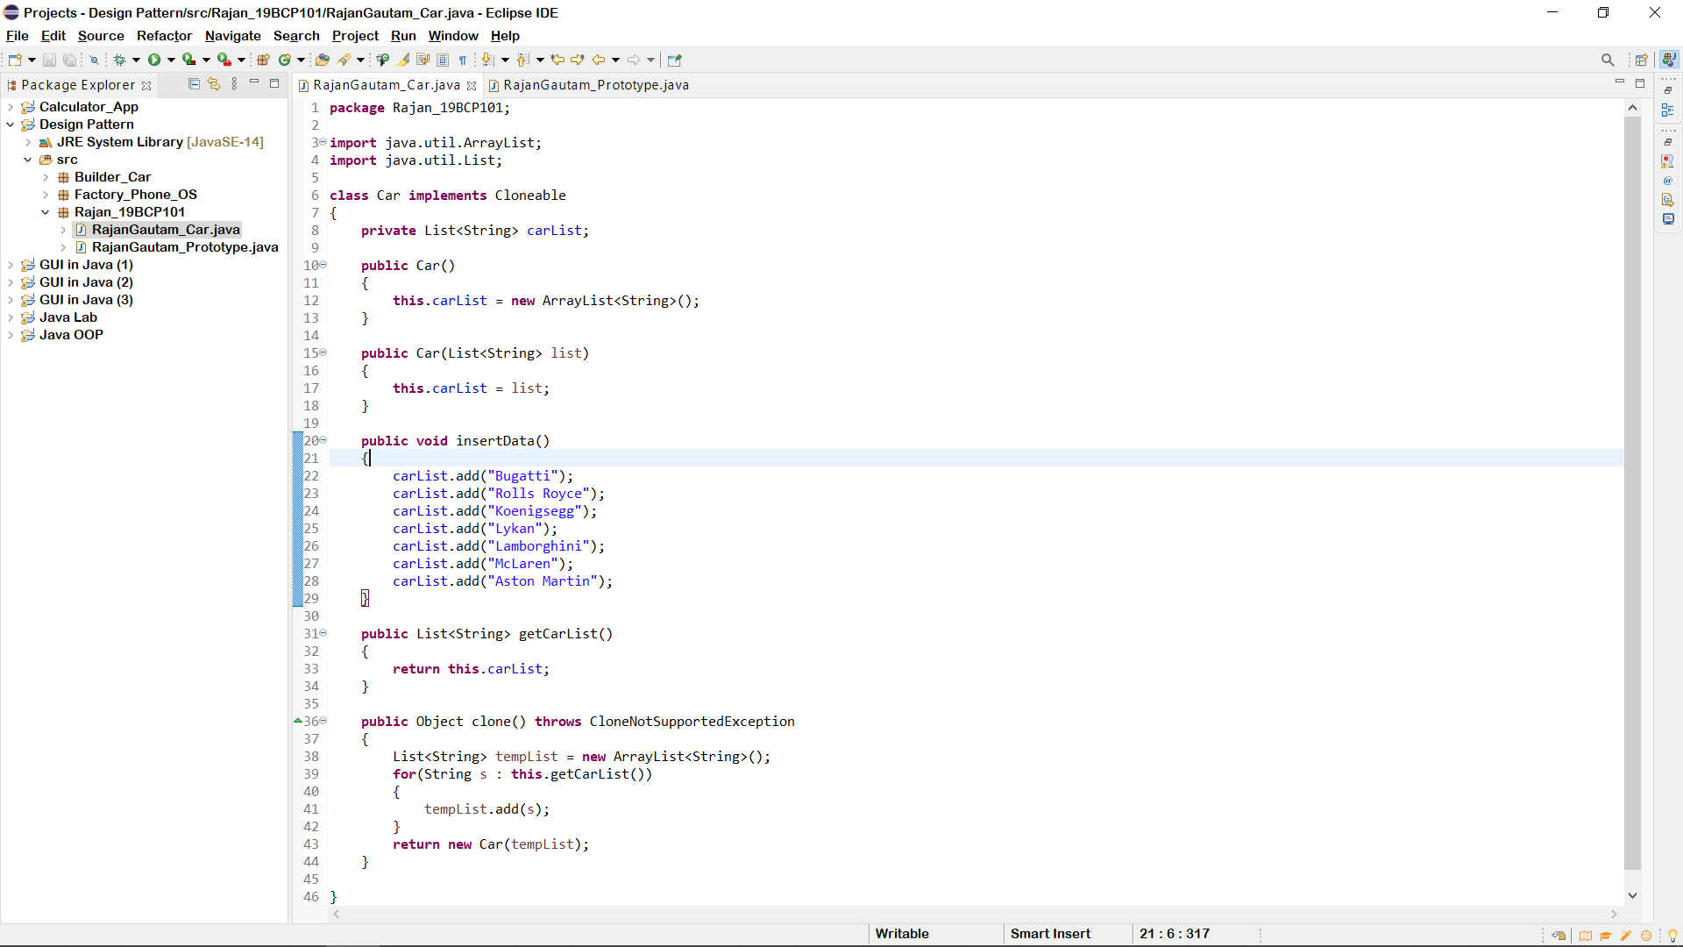

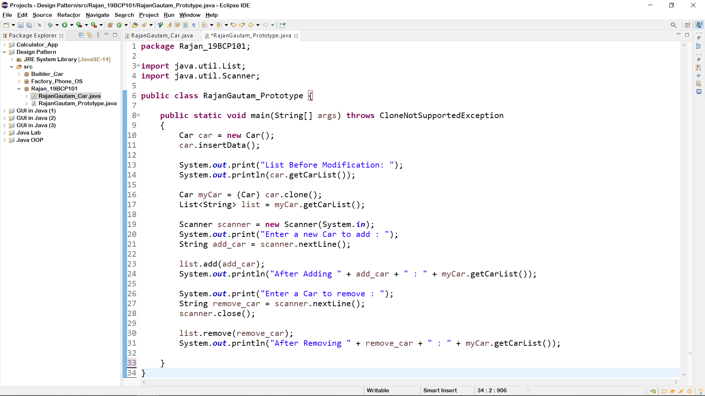

## SCREENSHOT OF OUTPUT:

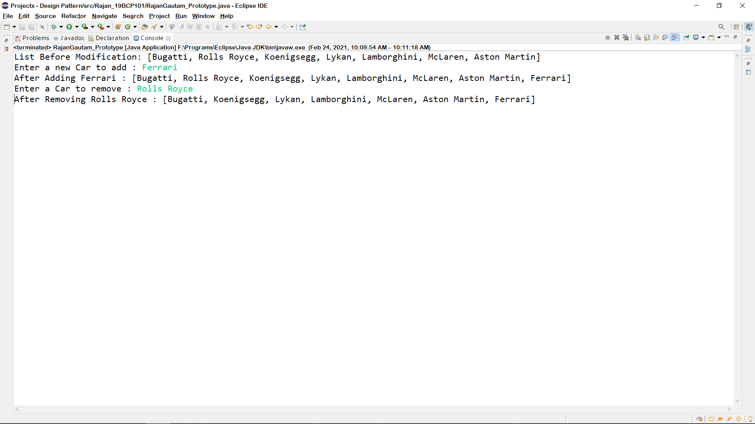

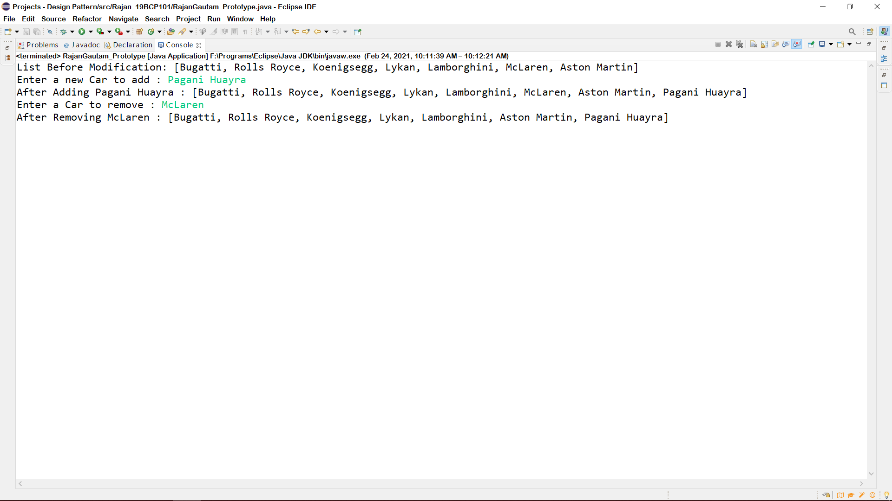

**GitHub Link:** [**https://github.com/rgautam320/Design-Pattern-Lab/tree/main/Prototype_Car**](https://github.com/rgautam320/Design-Pattern-Lab/tree/main/Prototype_Car)